IFT 266 Introduction to Network Information Communication Technology (ICT)
Lab 30
Global Unicast Address (GUA) Configuration

- Open the file you save from Lab 29 or create the topology from scratch. If you create from scratch, then you will need to configure the router with link local addresses on the interfaces.

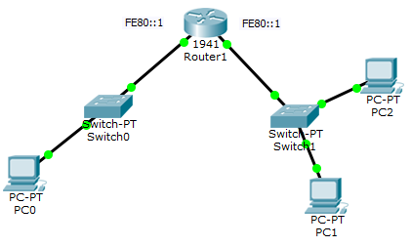

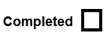

- We have link local addressing and IPv6 routing enabled and all these devices have link local addresses. Now we need to setup global unicast addresses that are routable so that the devices can communicate from one network to another. We need to create two IPv6 networks with separate addresses for each subnet.

- For demonstration/teaching purposes, Cisco allows us to use a global unicast address that we can subnet and this address is in the range of routable IPv6 addresses.

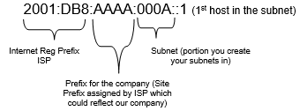

- First 64 bits = network prefix (network portion of IPv6 address)
- Last 64 bits = identify interface id or the host portion (identifies a host on the network). All 0s + 1 so first host on the network - good address to give router interface.

- So 2001:DB8:AAAA:A::1 (in compressed format) is Subnet A + 1st host in address.
- To make a GUA for the second subnet (Subnet B), change the address to 2001:DB8:AAAA:B::1

- All we need to do is configure the router with this addressing. When we do configure the routers with the GUAs, we need to include the slash / for the network prefix i.e. /64 where it identifies that the first 64 bits from left to right) are for network portion.

- Open the router and enter the following commands

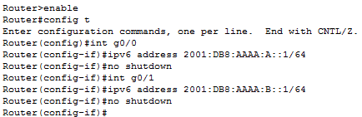

- Now the global unicast addresses are setup on each router interface.

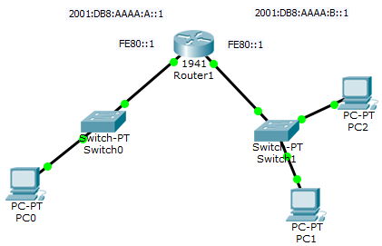

- Go to PC0 and to IP configuration to configure the GUA on the PC. We can use Auto Config (SLAAC) and will automatically contact the router, figure out what the subnet is and then autoconfigure its own address and receive the gateway address from the router.
- Select Auto Config and all the information should be applied. The PC figured out that’s its Subnet A, auto configured its own GUA by contacting the router and figuring out what the network prefix is and the IPv6 gateway (FE80::1);

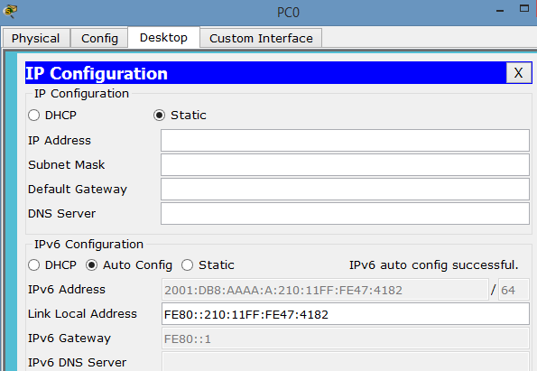

- Repeat the same autoconfiguration for PC1 and PC2.

- We will now test to see if we can ping across the networks. To ping across the networks, we can’t select the IPv6 address in PC0 (it’s greyed out), so copy the link local address from PC0 and go to PC1 and then open the command prompt and ping 2001:DB8:AAAA:A + link local address (210:11FF:FE47:4182)
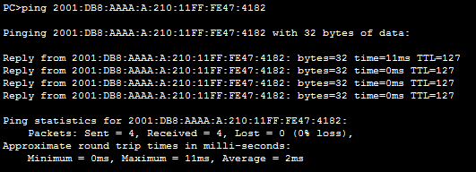

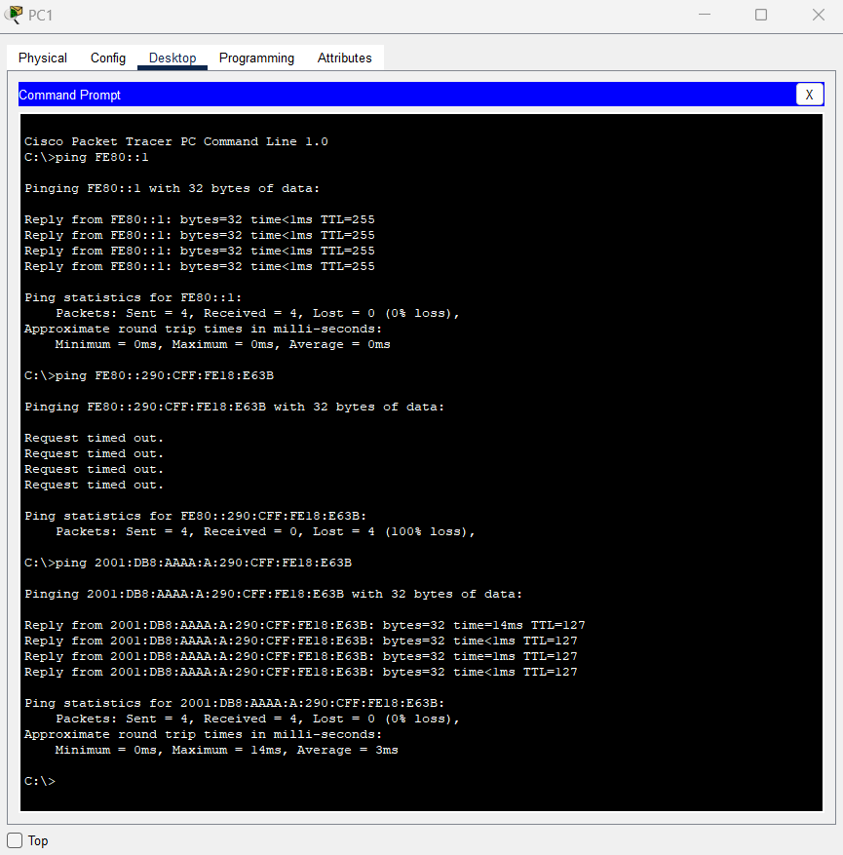

- Repeat the same ping process for other PCs to show the communication from network to network.

- You should also be able to ping the gateway from the PC i.e. ping 2001:DB8:AAAA:A::1 (on PC0)

- If the ping does not work, make sure the IPv6 gateway address is still on the PCs configuration (auto config will loose the gateway address). Just select static and then Auto Config and the address will reappear.

